|  |  |  |
| --- | --- | --- |
|  |  |  |
|  |  |  |
|  |  |  |
|  |  |  |
|  |  |  |
|  |  |  |

# Table of contents

|  |  |  |
| --- | --- | --- |
| **Sr. No.** | **Particulars** | **Page No.** |
| 1 | Denmark | 1 |
| 2 | Macroeconomics Indicators | 2 |
| 3 | NOVO Nordisk | 4 |
| 4 | Carlsberg | 11 |
| 5 | Coloplast | 18 |
| 6 | DSV AS | 25 |
| 7 | Demant | 32 |
| 8 | Ranking | 39 |
| 9 | References | 40 |

**GDP**

1990

1991

1992

1993

1994

1995

1996

1997

1998

1999

2000

2001

2002

2003

2004

2005

2006

2007

2008

2009

2010

2011

2012

2013

2014

2015

2016

2017

2018

2019

2020

2021

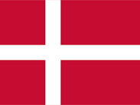Denmark

* Denmark, officially the Kingdom of Denmark, is a country located in north-central Europe. 16,577 square miles (42,934 sq km). Its territory includes the self-governing dependencies of Greenland and the Faroe Islands.
* Estimated population in 2022: 5,893,000. Copenhagen is the capital. The majority of the people are Danish. Danish is the language (official). Christianity (primarily Evangelical Lutheran [official]); also, Islam.
* Danish krone is the currency. Denmark is located between the North and Baltic seas, including the Jutland peninsula and an archipelago to the east.
* Zealand (Sjaelland) and Funen (Fyn), the two largest islands, account for roughly one-fourth of the country's total land area. Denmark has a generally temperate and often wetclimate due to its 4,500- mile (7,300-kilometer) coastline. Its economy is a mix of services and manufacturing.
* From 1397 to 1523, Scandinavia was united under Danish rule; a series of crippling wars with Sweden in the 17th century resulted in the Treaty of Copenhagen (1660), which established the modern Scandinavian borders.
* Denmark gained and lost various other territories, including Norway, in the nineteenthand twentieth centuries; it had three constitutions between 1849 and 1915 and was occupied by Nazi Germany from 1940 to 1945. Denmark, a founding member of NATO(1949), adopted its current constitution in 1953.
* Denmark's currency, the *krone* (DKK), is pegged at approximately 7.46 kroner per euro through the ERM II.
* Ranked by turnover in Denmark, the largest Danish companies are A.P. Møller-Mærsk (international shipping), Novo Nordisk (pharmaceuticals), DSV (transport), and Carlsberg Group (beer).



**Denmark GDP**

$450 Billion

$400 Billion

$350 Billion

$300 Billion

$250 Billion

$200 Billion

$150 Billion

$100 Billion

$50 Billion

$ Billion

**Years**

# Indicators

1. **GDP (Value Added Formula):** Gross Domestic Product is a total monetary or market value of all finished goods and services produced within a country’s boarders in a specific time period.
2. **Employment:** Employment means the state of having a job or being employed.
3. **Per Capita Income:** Per Capita Income is a measure of the amount of money earned per person in a nation or geographic region.
4. **Market capitalization:** Market Capitalization refers to the market value of all domestic listed company of a country.
5. **Capital Formation:** The net capital accumulation during an accounting period for a particular country.

NOVO Nordisk

* We are a global healthcare company, founded in 1923 and headquartered just outside Copenhagen, Denmark.
* The Novo Group is a group of independent companies controlled by the Novo Nordisk Foundation. Novo Holdings serves as the holding company of the Group.
* Through Novo Holdings, the Foundation owns the controlling stake in the two major companies of the Novo Group: Novo Nordisk A/S and Novozymes A/S, both of which are publicly listed. Novo Holdings owns more than 25% of the ordinary share capital of the two companies and controls more than 70% of the votes given our ownership of all the preferred (A) shares of Novo Nordisk and Novozymes.
* The company reported revenues of (Danish Krone) DKK140,800 million for the fiscal year ended December 2021 (FY2021), an increase of 10.9% over FY2020. In FY2021, the company's operating margin was 41.7%, compared to an operating margin of 4% in FY2020. In FY2021, the company recorded a net margin of 33.9%, compared to a net margin of 33.2 in FY2020.

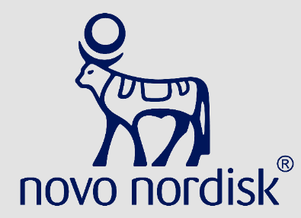

GDP

|  |  |  |  |  |  |  |  |
| --- | --- | --- | --- | --- | --- | --- | --- |
| **Years** | Denmark ($  Millions) | NOVO | Percentage | **Years** | Denmark ($  Millions) | NOVO | Percentage |
| **1991** | 204830 | 9369.6 | 0.000005% | **2007** | 294567 | 50851 | 0.000017% |
| **1992** | 208838 | 12370.8 | 0.000006% | **2008** | 293059 | 55164 | 0.000019% |
| **1993** | 208861 | 14213.5 | 0.000007% | **2009** | 278680 | 61094 | 0.000022% |
| **1994** | 219998 | 16004 | 0.000007% | **2010** | 283894 | 70465 | 0.000025% |
| **1995** | 226659 | 15997 | 0.000007% | **2011** | 287689 | 75779 | 0.000026% |
| **1996** | 233232 | 17378 | 0.000007% | **2012** | 288341 | 87569 | 0.000030% |
| **1997** | 240837 | 19639 | 0.000008% | **2013** | 291032 | 93124 | 0.000032% |
| **1998** | 246180 | 22553 | 0.000009% | **2014** | 295745 | 100163 | 0.000034% |
| **1999** | 253437 | 20006 | 0.000008% | **2015** | 302673 | 120685 | 0.000040% |
| **2000** | 262933 | 24783 | 0.000009% | **2016** | 312498 | 126121 | 0.000040% |
| **2001** | 265097 | 28536 | 0.000011% | **2017** | 321316 | 127069 | 0.000040% |
| **2002** | 266334 | 31106 | 0.000012% | **2018** | 327708 | 128167 | 0.000039% |
| **2003** | 267372 | 32689 | 0.000012% | **2019** | 334638 | 139662 | 0.000042% |
| **2004** | 274507 | 36194 | 0.000013% | **2020** | 327738 | 145509 | 0.000044% |
| **2005** | 280921 | 41542 | 0.000015% | **2021** | 343120 | 160421 | 0.000047% |
| **2006** | 291913 | 47143 | 0.000016% |  | | | |

**Source: Bloomberg and World Bank**

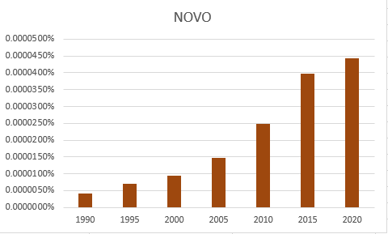

Employment

|  |  |  |  |  |  |  |  |
| --- | --- | --- | --- | --- | --- | --- | --- |
| **Years** | Population Employed | NOVO Nordisk | | **Years** | Population Employed | NOVO Nordisk | |
| Number of  Employees | Percentage | Number of  Employees | Percentage |
| **1991** | 31,77,986 | 9,627 | 0.3029% | **2007** | 34,52,339 | 25,516 | 0.7391% |
| **1992** | 32,04,181 | 10,733 | 0.3350% | **2008** | 34,43,676 | 26,575 | 0.7717% |
| **1993** | 31,20,856 | 11,648 | 0.3732% | **2009** | 33,28,383 | 28,809 | 0.8656% |
| **1994** | 30,82,267 | 12,847 | 0.4168% | **2010** | 32,49,777 | 30,483 | 0.9380% |
| **1995** | 31,44,943 | 12,997 | 0.4133% | **2011** | 32,39,343 | 32,632 | 1.0074% |
| **1996** | 31,96,791 | 13,196 | 0.4128% | **2012** | 32,12,358 | 34,286 | 1.0673% |
| **1997** | 32,71,726 | 13,785 | 0.4213% | **2013** | 31,94,166 | 38,436 | 1.2033% |
| **1998** | 32,83,046 | 14,516 | 0.4422% | **2014** | 32,17,627 | 40,957 | 1.2729% |
| **1999** | 33,21,760 | 15,021 | 0.4522% | **2015** | 32,66,241 | 41,122 | 1.2590% |
| **2000** | 33,42,813 | 12,698 | 0.3799% | **2016** | 33,19,783 | 41,971 | 1.2643% |
| **2001** | 33,46,024 | 16,141 | 0.4824% | **2017** | 33,50,722 | 42,076 | 1.2557% |
| **2002** | 33,78,074 | 17,073 | 0.5054% | **2018** | 33,97,909 | 42,672 | 1.2558% |
| **2003** | 33,39,137 | 18,756 | 0.5617% | **2019** | 34,44,405 | 43,258 | 1.2559% |
| **2004** | 33,77,935 | 20,725 | 0.6135% | **2020** | 34,12,654 | 45,323 | 1.3281% |
| **2005** | 33,86,007 | 22,007 | 0.6499% | **2021** | 34,64,258 | 47,792 | 1.3796% |
| **2006** | 34,45,001 | 23,613 | 0.6854% |  | | | |



**NUMBER OF EMPLOYEES NOVO NORDISK % OF**

**POPULATION EMPLOYED OF DENMARK**

Number of Employees NOVO NORDISK % of POPULATION EMPLOYED OF DENMARK

**1.3281%**

**1.3796%**

**1.2590%**

**0.9380%**

**0.6499%**

**0.4133%**

**0.3799%**

**0.3029%**

1991

1995

2000

2005

2010

2015

2020

2021

National Per Capita Income

|  |  |  |  |  |  |  |  |
| --- | --- | --- | --- | --- | --- | --- | --- |
| **Years** | Adjusted net national income per capita of  Denmark ($) | Novo Nordisk | | **Years** | Adjusted net national income per capita of  Denmark ($) | Novo Nordisk | |
| Net income per employee  ($) | Percentage | Net income per employee  ($) | Percentage |
| **1991** | 21,534.74 | 15,128.82 | 70% | **2007** | 47,957.84 | 61,447.47 | 128% |
| **1992** | 23,748.69 | 19,734.58 | 83% | **2008** | 52,148.61 | 71,596.81 | 137% |
| **1993** | 22,305.79 | 18,898.00 | 85% | **2009** | 47,483.32 | 69,999.13 | 147% |
| **1994** | 24,413.92 | 17,585.45 | 72% | **2010** | 47,959.01 | 84,169.04 | 176% |
| **1995** | 28,870.71 | 21,492.57 | 74% | **2011** | 51,228.62 | 97,912.99 | 191% |
| **1996** | 29,023.87 | 23,524.36 | 81% | **2012** | 48,814.47 | 1,07,981.56 | 221% |
| **1997** | 26,622.04 | 24,327.76 | 91% | **2013** | 51,794.62 | 1,16,698.22 | 225% |
| **1998** | 27,247.51 | 24,808.00 | 91% | **2014** | 53,767.20 | 1,15,214.02 | 214% |
| **1999** | 27,394.91 | 19,093.60 | 70% | **2015** | 45,788.04 | 1,26,159.20 | 276% |
| **2000** | 24,600.59 | 30,118.33 | 122% | **2016** | 46,821.19 | 1,34,330.46 | 287% |
| **2001** | 24,788.12 | 28,778.47 | 116% | **2017** | 49,134.60 | 1,37,624.01 | 280% |
| **2002** | 26,747.43 | 30,528.44 | 114% | **2018** | 52,848.82 | 1,43,454.32 | 271% |
| **2003** | 32,660.80 | 39,267.59 | 120% | **2019** | 51,399.61 | 1,35,013.48 | 263% |
| **2004** | 38,088.41 | 40,451.21 | 106% | **2020** | 52,666.35 | 1,42,408.17 | 270% |
| **2005** | 40,314.94 | 44,490.10 | 110% | **2021** | NA | 1,58,921.91 | NA |
| **2006** | 43,110.23 | 46,023.48 | 107% |  | | | |

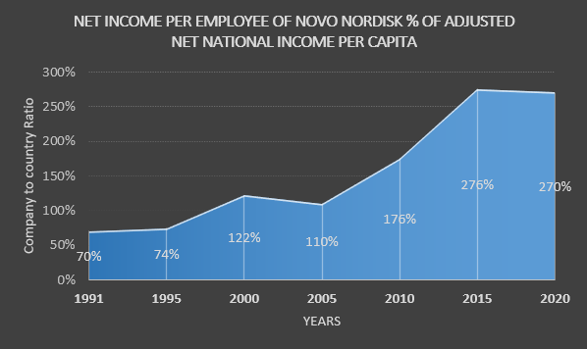

Market Capitalization

|  |  |  |  |  |  |  |  |
| --- | --- | --- | --- | --- | --- | --- | --- |
| **Years** | Market cap of DENMARK in BILLION  US $ | NOVO NORDISK | | **Years** | Market cap in DENMARK in BILLION  US $ | NOVO NORDISK | |
| Market Cap in billions | Percentage | Market Cap in billions | Percentages |
| **1995** | 56.22 | 5.12192 | 9% | **2007** | NA | 40.70094 | NA |
| **1996** | 71.07 | 6.57325 | 9% | **2008** | NA | 30.89852 | NA |
| **1997** | 93.77 | 10.73596 | 11% | **2009** | NA | 37.59201 | NA |
| **1998** | 98.87 | 9.75713 | 10% | **2010** | 207.2397 | 67.67666 | 33% |
| **1999** | 97.45 | 9.42918 | 10% | **2011** | 164.55296 | 66.74105 | 41% |
| **2000** | 111.81 | 13.52988 | 12% | **2012** | 198.08958 | 90.78752 | 46% |
| **2001** | 85.14 | 14.51157 | 17% | **2013** | 248.53962 | 97.27233 | 39% |
| **2002** | 76.74 | 10.25548 | 13% | **2014** | 282.4317 | 109.98651 | 39% |
| **2003** | 121.64 | 14.374 | 12% | **2015** | 367.683516 | 148.34497 | 40% |
| **2004** | 151.34 | 19.32956 | 13% | **2016** | 351.832491 | 90.48081 | 26% |
| **2005** | NA | 18.19893 | NA | **2017** | 397.010636 | 132.02384 | 33% |
| **2006** | NA | 28.04324 | NA |  | | | |

**Source: Bloomberg and World Bank**



NOVONORDISK Market Cap % Market Cap of Denmark

9.110%

30.572%

12.101%

12.772%

40.346%

32.656%

1995 2000 2004 2010 2015 2020

Capital Formation

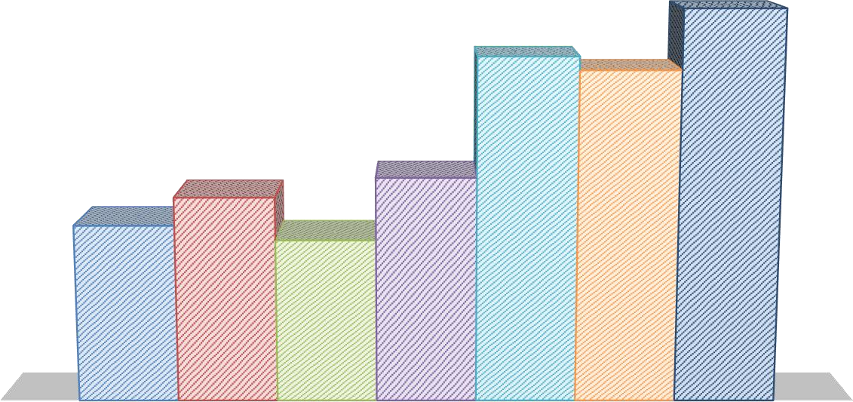

**NOVO NORDISK TOTAL EQUITY % OF CAPITAL**

**FORMATION OF DENMARK**

FY 1992 FY 1995 FY 2000 FY 2005 FY 2010 FY 2015 FY 2020

14%

13%

12%

11%

11%

10%

8%

7%

7%

6%

6%

5%

4%

2%

0%

NOVO NORDISK Total Equity % OF CAPITAL FORMATION of Denmark

|  |  |  |  |  |  |  |  |
| --- | --- | --- | --- | --- | --- | --- | --- |
| **Years** | Capital Formation of DENMARK In  US Billion $ | NOVO NORDISK | | **Years** | Capital Formation of DENMARK  In US Billion  $ | NOVO NORDISK | |
| Total Equity in Billions of  USD | Percentage | Total Equity in Billions  of USD | Percentage |
| **1991** | 27.3 | 1.6264 | 6% | **2007** | 80.74 | 6.2948 | 8% |
| **1992** | 28.96 | 1.7037 | 6% | **2008** | 84.75 | 6.1816 | 7% |
| **1993** | 24.88 | 1.7598 | 7% | **2009** | 61.32 | 6.8828 | 11% |
| **1994** | 29.26 | 2.1723 | 7% | **2010** | 58.2 | 6.6287 | 11% |
| **1995** | 38.27 | 2.6062 | 7% | **2011** | 65.8 | 6.529 | 10% |
| **1996** | 37.65 | 2.7476 | 7% | **2012** | 63.66 | 7.1874 | 11% |
| **1997** | 38.29 | 2.6919 | 7% | **2013** | 67.65 | 7.8684 | 12% |
| **1998** | 40.1 | 2.9248 | 7% | **2014** | 70.9 | 6.5484 | 9% |
| **1999** | 37.7 | 2.06 | 5% | **2015** | 62.45 | 6.8385 | 11% |
| **2000** | 36.69 | 1.9808 | 5% | **2016** | 68.18 | 6.4215 | 9% |
| **2001** | 35.96 | 2.4125 | 7% | **2017** | 73.24 | 8.0448 | 11% |
| **2002** | 38.13 | 3.2417 | 9% | **2018** | 80.64 | 7.9511 | 10% |
| **2003** | 45.63 | 4.1748 | 9% | **2019** | 75.72 | 8.6549 | 11% |
| **2004** | 54.53 | 4.8307 | 9% | **2020** | 80.5 | 10.4031 | 13% |
| **2005** | 58.73 | 4.3824 | 7% | **2021** | 91.49 | 10.8318 | 12% |
| **2006** | 68.74 | 5.3281 | 8% |  | | | |

# Carlsberg Group in Denmark

* JC Jacobsen established the Carlsberg brewery at Valby, Copenhagen, on November 10th, 1847.
* Carlsberg and Tuborg, the other major Danish brewery, combined in 1970. After merging with Coca- Cola Tapperierne Denmark in 2001, Carlsberg Denmark became a wholly owned part of the Carlsberg Group in 2000.
* Also owned by Carlsberg since 1964, the Wiibroe brewery in North Zealand started producing Wiibroe beer in 1998.
* Copenhagen continues to be the home of the Carlsberg Group and Carlsberg Denmark. It conducts business in Asia, Eastern Europe, and Western Europe. The business's main office is in Copenhagen, Denmark.
* For the fiscal year that ended in December 2021 (FY2021), the firm recorded revenues of (Danish Krone) DKK60,097 million, an increase of 2.7% over FY2020.



GDP

|  |  |  |  |  |  |  |  |
| --- | --- | --- | --- | --- | --- | --- | --- |
| **Years** | Denmark ($ Millions) | Carlsberg | Percentage | **Years** | Denmark ($ Millions) | Carlsberg | Percentage |
| **1991** | 204830 | 10242 | 0.000005% | **2007** | 294567 | 48568 | 0.000016% |
| **1992** | 208838 | 12602 | 0.000006% | **2008** | 293059 | 65172 | 0.000022% |
| **1993** | 208861 | 13751 | 0.000007% | **2009** | 278680 | 62983 | 0.000023% |
| **1994** | 219998 | 14708 | 0.000007% | **2010** | 283894 | 64245 | 0.000023% |
| **1995** | 226659 | 14806 | 0.000007% | **2011** | 287689 | 67911 | 0.000024% |
| **1996** | 233232 | 15603 | 0.000007% | **2012** | 288341 | 71009 | 0.000025% |
| **1997** | 240837 | 16861 | 0.000007% | **2013** | 291032 | 68942 | 0.000024% |
| **1998** | 246180 | 24150 | 0.000010% | **2014** | 295745 | 68799 | 0.000023% |
| **1999** | 253437 | 26304 | 0.000010% | **2015** | 302673 | 69171 | 0.000023% |
| **2000** | 262933 | 36895 | 0.000014% | **2016** | 312498 | 66577 | 0.000021% |
| **2001** | 265097 | 37321 | 0.000014% | **2017** | 321316 | 64489 | 0.000020% |
| **2002** | 266334 | 38324 | 0.000014% | **2018** | 327708 | 66938 | 0.000020% |
| **2003** | 267372 | 37301 | 0.000014% | **2019** | 334638 | 70653 | 0.000021% |
| **2004** | 274507 | 39167 | 0.000014% | **2020** | 327738 | 63154 | 0.000019% |
| **2005** | 280921 | 40913 | 0.000015% | **2021** | 343120 | 65488 | 0.000019% |
| **2006** | 291913 | 44303 | 0.000015% |  |  |  |  |

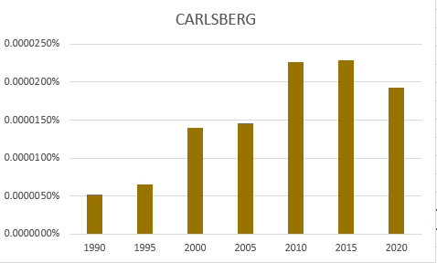

Employment

|  |  |  |  |  |  |  |  |
| --- | --- | --- | --- | --- | --- | --- | --- |
| Years | Population Employed | Carlsberg | | Years | Population Employed | Carlsberg | |
| Number of  Employees | Percentage | Number of  Employees | Percentage |
| 1991 | 31,77,986 | 11,500 | 0.3619% | 2007 | 34,52,339 | 33,420 | 0.9680% |
| 1992 | 32,04,181 | 13,777 | 0.4300% | 2008 | 34,43,676 | 45,505 | 1.3214% |
| 1993 | 31,20,856 | 17,762 | 0.5691% | 2009 | 33,28,383 | 43,271 | 1.3001% |
| 1994 | 30,82,267 | 17,481 | 0.5671% | 2010 | 32,49,777 | 41,402 | 1.2740% |
| 1995 | 31,44,943 | 17,563 | 0.5585% | 2011 | 32,39,343 | 42,670 | 1.3172% |
| 1996 | 31,96,791 | 18,519 | 0.5793% | 2012 | 32,12,358 | 41,708 | 1.2984% |
| 1997 | 32,71,726 | 18,081 | 0.5526% | 2013 | 31,94,166 | 38,705 | 1.2117% |
| 1998 | 32,83,046 | 20,589 | 0.6271% | 2014 | 32,17,627 | 46,882 | 1.4570% |
| 1999 | 33,21,760 | 21,906 | 0.6595% | 2015 | 32,66,241 | 47,464 | 1.4532% |
| 2000 | 33,42,813 | 23,641 | 0.7072% | 2016 | 33,19,783 | 42,062 | 1.2670% |
| 2001 | 33,46,024 | 27,368 | 0.8179% | 2017 | 33,50,722 | 41,430 | 1.2365% |
| 2002 | 33,78,074 | 28,466 | 0.8427% | 2018 | 33,97,909 | 40,837 | 1.2018% |
| 2003 | 33,39,137 | 31,531 | 0.9443% | 2019 | 34,44,405 | 41,248 | 1.1975% |
| 2004 | 33,77,935 | 31,703 | 0.9385% | 2020 | 34,12,654 | 40,010 | 1.1724% |
| 2005 | 33,86,007 | 30,492 | 0.9005% | 2021 | 34,64,258 | 39,375 | 1.1366% |
| 2006 | 34,45,001 | 31,680 | 0.9196% |  | | | |



**NUMBER OF EMPLOYEES CARLSBERG % OF POPULATION**

**EMPLOYED OF DENMARK**

Number of Employees Carlsberg % of POPULATION EMPLOYED OF DENMARK

**1.4532%**

**1.2740%**

**1.1724%**

**1.1366%**

**0.9005%**

**0.7072%**

**0.5585%**

**0.3619%**

1991

1995

2000

2005

2010

2015

2020

2021

National Per capita income

|  |  |  |  |  |  |  |  |
| --- | --- | --- | --- | --- | --- | --- | --- |
| **Years** | Adjusted net national income per capita of  Denmark ($) | Carlsberg | | **Years** | Adjusted net national income per capita of  Denmark ($) | Carlsberg | |
| Net income per employee  ($) | Percentage | Net income per employee  ($) | Percentage |
| **1991** | 21,534.74 | 11,199.69 | 52% | **2007** | 47,957.84 | 12,645.31 | 26% |
| **1992** | 23,748.69 | 10,163.83 | 43% | **2008** | 52,148.61 | 11,362.47 | 22% |
| **1993** | 22,305.79 | 8,139.97 | 36% | **2009** | 47,483.32 | 15,589.51 | 33% |
| **1994** | 24,413.92 | 7,049.83 | 29% | **2010** | 47,959.01 | 23,023.47 | 48% |
| **1995** | 28,870.71 | 9,982.14 | 35% | **2011** | 51,228.62 | 22,550.92 | 44% |
| **1996** | 29,023.87 | 10,059.16 | 35% | **2012** | 48,814.47 | 23,222.82 | 48% |
| **1997** | 26,622.04 | 10,777.23 | 40% | **2013** | 51,794.62 | 25,175.46 | 49% |
| **1998** | 27,247.51 | 11,743.22 | 43% | **2014** | 53,767.20 | 16,795.34 | 31% |
| **1999** | 27,394.91 | 7,865.59 | 29% | **2015** | 45,788.04 | -9,174.36 | -20% |
| **2000** | 24,600.59 | 11,177.75 | 45% | **2016** | 46,821.19 | 15,855.05 | 34% |
| **2001** | 24,788.12 | 5,243.36 | 21% | **2017** | 49,134.60 | 4,615.01 | 9% |
| **2002** | 26,747.43 | 4,520.49 | 17% | **2018** | 52,848.82 | 20,602.19 | 39% |
| **2003** | 32,660.80 | 4,620.38 | 14% | **2019** | 51,399.61 | 23,879.29 | 46% |
| **2004** | 38,088.41 | 5,802.57 | 15% | **2020** | 52,666.35 | 23,084.92 | 44% |
| **2005** | 40,314.94 | 6,078.09 | 15% | **2021** | NA | 27,651.47 | NA |
| **2006** | 43,110.23 | 10,016.87 | 23% |  | | | |

**Source: Bloomberg and World Bank**

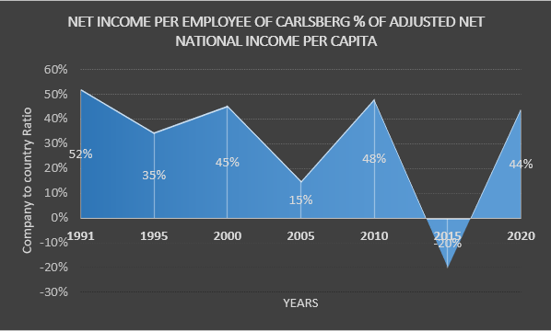

Market Capitalization

|  |  |  |  |  |  |  |  |
| --- | --- | --- | --- | --- | --- | --- | --- |
| **Years** | Market cap in DENMARK in BILLION US $ | CARLSBERG | | **Years** | Market cap in DENMARK in BILLION  US $ | CARLSBERG | |
| Market Cap in billions | Percentage | Market Cap in billions | Percentage |
| **1995** | 56.22 | 3.13327 | 6% | **2009** | NA | 11.33221 | NA |
| **1996** | 71.07 | 3.87349 | 5% | **2010** | 207.2397 | 15.36052 | 7% |
| **1997** | 93.77 | 3.53928 | 4% | **2011** | 164.55296 | 10.84103 | 7% |
| **1998** | 98.87 | 3.79836 | 4% | **2012** | 198.08958 | 15.1059 | 8% |
| **1999** | 97.45 | 2.34195 | 2% | **2013** | 248.53962 | 17.07483 | 7% |
| **2000** | 111.81 | 3.63996 | 3% | **2014** | 282.4317 | 11.87074 | 4% |
| **2001** | 85.14 | 2.5284 | 3% | **2015** | 367.683516 | 13.60468 | 4% |
| **2002** | 76.74 | 2.58438 | 3% | **2016** | 351.832491 | 13.18988 | 4% |
| **2003** | 121.64 | 2.75672 | 2% | **2017** | 397.010636 | 18.35451 | 5% |
| **2004** | 151.34 | 3.69749 | 2% | **2018** | 341.00462 | 16.2064 | 5% |
| **2005** | NA | 3.96578 | NA | **2019** | 427.121732 | 22.78356 | 5% |
| **2006** | NA | 7.32489 | NA | **2020** | 530.168821 | 23.73585 | 4% |
| **2007** | NA | 8.98152 | NA | **2021** | 637.84149 | 25.1202 | 4% |
| **2008** | NA | 5.20805 | NA |  | | | |

## Source: Bloomberg and World Bank

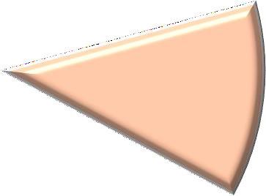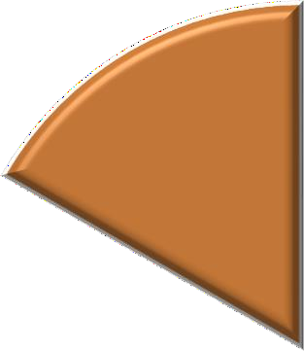

CARLSBERG Market Cap % Market Cap of Denmark

4.477%

5.573%

3.700%

3.255%

2.443%

7.412%

1995 2000 2004 2010 2015 2020

Capital Formation

|  |  |  |  |  |  |  |  |
| --- | --- | --- | --- | --- | --- | --- | --- |
| **Years** | Capital Formation of DENMARK In  US Billion $ | CARLSBERG | | **Years** | Capital Formation of DENMARK In US  Billion $ | CARLSBERG | |
| Total Equity in Billions | Percentage | Total Equity in Billions | Percentage |
| **1991** | 27.3 | 0.9663 | 4% | **2007** | 80.74 | 3.901 | 5% |
| **1992** | 28.96 | 1.2752 | 4% | **2008** | 84.75 | 11.2279 | 13% |
| **1993** | 24.88 | 1.1707 | 5% | **2009** | 61.32 | 11.4583 | 19% |
| **1994** | 29.26 | 1.3089 | 4% | **2010** | 58.2 | 12.4861 | 21% |
| **1995** | 38.27 | 1.5248 | 4% | **2011** | 65.8 | 12.4885 | 19% |
| **1996** | 37.65 | 1.5587 | 4% | **2012** | 63.66 | 13.028 | 20% |
| **1997** | 38.29 | 1.5643 | 4% | **2013** | 67.65 | 13.1238 | 19% |
| **1998** | 40.1 | 1.7569 | 4% | **2014** | 70.9 | 9.1003 | 13% |
| **1999** | 37.7 | 1.6975 | 5% | **2015** | 62.45 | 6.8767 | 11% |
| **2000** | 36.69 | 1.338 | 4% | **2016** | 68.18 | 7.6104 | 11% |
| **2001** | 35.96 | 2.2952 | 6% | **2017** | 73.24 | 7.998 | 11% |
| **2002** | 38.13 | 2.444 | 6% | **2018** | 80.64 | 7.3453 | 9% |
| **2003** | 45.63 | 3.0172 | 7% | **2019** | 75.72 | 6.9178 | 9% |
| **2004** | 54.53 | 3.0605 | 6% | **2020** | 80.5 | 7.1236 | 9% |
| **2005** | 58.73 | 3.0918 | 5% | **2021** | 91.49 | 7.465 | 8% |
| **2006** | 68.74 | 3.3585 | 5% |  | | | |

**Source: Bloomberg and World Bank**

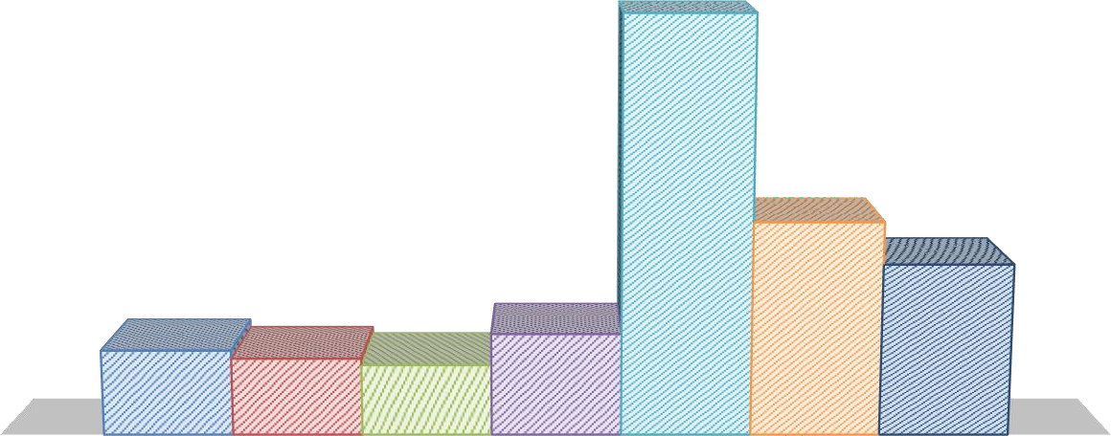

**CARLSBERG TOTAL EQUITY % OF CAPITAL FORMATION**

**OF DENMARK**

FY 1992 FY 1995 FY 2000 FY 2005 FY 2010 FY 2015 FY 2020

25.000%

21.454%

20.000%

15.000%

11.012%

10.000%

8.849%

5.000%

4.403%

5.264%

3.984%

3.647%

0.000%

CARLSBERG Total Equity % OF CAPITAL FORMATION of Denmark

# COLOPLAST

* Founded in 1957 it manufactures and provides goods and services for ostomy care, urological care, continence care, and skin and wound care is Coloplast A/S (Coloplast).
* Hospitals, institutes, wholesalers, and retailers across Europe, Africa, South America, Asia, Russia, Australia, and North America can purchase Coloplast goods through subsidiaries and distributors.
* Denmark's Humlebaek serves as the home base for Coloplast.
* For the fiscal year that ended in September 2021 (FY2021), the firm recorded revenues of (Danish Krone) DKK19,426 million, an increase of 4.8% over FY2020. For the second quarter that concluded in March 2022, the firm recorded revenues of DKK5,502 million, an increase of 6.4% from the prior quarter.

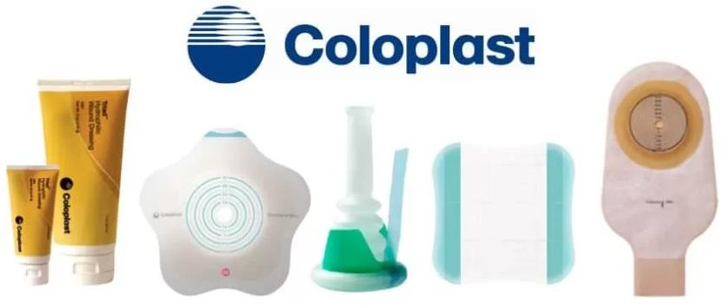

GDP

|  |  |  |  |  |  |  |  |
| --- | --- | --- | --- | --- | --- | --- | --- |
| **Years** | Denmark ($ Millions) | Coloplast | Percentage | **Years** | Denmark ($ Millions) | Coloplast | Percentage |
| **1991** | 204830 | 991.1 | 0.00000048% | **2007** | 294567 | 8982 | 0.00000305% |
| **1992** | 208838 | 1121.9 | 0.00000054% | **2008** | 293059 | 9687 | 0.00000331% |
| **1993** | 208861 | 1434.2 | 0.00000069% | **2009** | 278680 | 9806 | 0.00000352% |
| **1994** | 219998 | 1592 | 0.00000072% | **2010** | 283894 | 10496 | 0.00000370% |
| **1995** | 226659 | 1869.1 | 0.00000082% | **2011** | 287689 | 11118 | 0.00000386% |
| **1996** | 233232 | 2172.1 | 0.00000093% | **2012** | 288341 | 12031 | 0.00000417% |
| **1997** | 240837 | 2647.9 | 0.00000110% | **2013** | 291032 | 12704 | 0.00000437% |
| **1998** | 246180 | 3003.7 | 0.00000122% | **2014** | 295745 | 13750 | 0.00000465% |
| **1999** | 253437 | 3479 | 0.00000137% | **2015** | 302673 | 15382 | 0.00000508% |
| **2000** | 262933 | 3984 | 0.00000152% | **2016** | 312498 | 16199 | 0.00000518% |
| **2001** | 265097 | 4543 | 0.00000171% | **2017** | 321316 | 17220 | 0.00000536% |
| **2002** | 266334 | 6193 | 0.00000233% | **2018** | 327708 | 18174 | 0.00000555% |
| **2003** | 267372 | 6493 | 0.00000243% | **2019** | 334638 | 19872 | 0.00000594% |
| **2004** | 274507 | 6991 | 0.00000255% | **2020** | 327738 | 20771 | 0.00000634% |
| **2005** | 280921 | 6930 | 0.00000247% | **2021** | 343120 | 21854 | 0.00000637% |
| **2006** | 291913 | 7553 | 0.00000259% |  | | | |

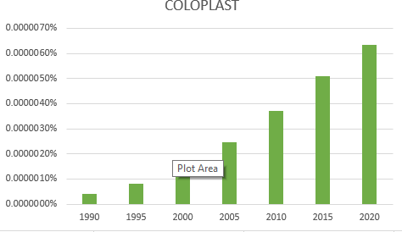

Employment

|  |  |  |  |  |  |  |  |
| --- | --- | --- | --- | --- | --- | --- | --- |
| **Years** | Population Employed | Coloplast | | **Years** | Population Employed | Coloplast | |
| Number of  Employees | Percentage | Number of  Employees | Percentage |
| **1991** | 31,77,986 | 1,528 | 0.0481% | **2007** | 34,52,339 | 7,274 | 0.2107% |
| **1992** | 32,04,181 | 1,633 | 0.0510% | **2008** | 34,43,676 | 7,567 | 0.2197% |
| **1993** | 31,20,856 | 1,734 | 0.0556% | **2009** | 33,28,383 | 7,139 | 0.2145% |
| **1994** | 30,82,267 | 1,996 | 0.0648% | **2010** | 32,49,777 | 7,284 | 0.2241% |
| **1995** | 31,44,943 | 2,400 | 0.0763% | **2011** | 32,39,343 | 7,328 | 0.2262% |
| **1996** | 31,96,791 | 2,588 | 0.0810% | **2012** | 32,12,358 | 7,875 | 0.2451% |
| **1997** | 32,71,726 | 2,888 | 0.0883% | **2013** | 31,94,166 | 8,412 | 0.2634% |
| **1998** | 32,83,046 | 3,269 | 0.0996% | **2014** | 32,17,627 | 9,071 | 0.2819% |
| **1999** | 33,21,760 | 3,745 | 0.1127% | **2015** | 32,66,241 | 9,706 | 0.2972% |
| **2000** | 33,42,813 | 3,771 | 0.1128% | **2016** | 33,19,783 | 10,275 | 0.3095% |
| **2001** | 33,46,024 | 4,203 | 0.1256% | **2017** | 33,50,722 | 10,905 | 0.3255% |
| **2002** | 33,78,074 | 5,515 | 0.1633% | **2018** | 33,97,909 | 11,569 | 0.3405% |
| **2003** | 33,39,137 | 6,032 | 0.1806% | **2019** | 34,44,405 | 12,234 | 0.3552% |
| **2004** | 33,77,935 | 6,084 | 0.1801% | **2020** | 34,12,654 | 12,250 | 0.3590% |
| **2005** | 33,86,007 | 6,159 | 0.1819% | **2021** | 34,64,258 | 12,875 | 0.3717% |
| **2006** | 34,45,001 | 7,220 | 0.2096% |  | | | |

**Source: Bloomberg and World Bank**



**NUMBER OF EMPLOYEES COLOPLAST % OF POPULATION**

**EMPLOYED OF DENMARK**

Number of Employees Coloplast % of POPULATION EMPLOYED OF DENMARK

**0.3590%**

**0.3717%**

**0.2972%**

**0.2241%**

**0.1819%**

**0.1128%**

**0.0763%**

**0.0481%**

1991

1995

2000

2005

2010

2015

2020

2021

National Per Capita Income

|  |  |  |  |  |  |  |  |
| --- | --- | --- | --- | --- | --- | --- | --- |
| **Years** | Adjusted net national income per capita of Denmark  ($) | Coloplast | | **Years** | Adjusted net national income per capita of Denmark  ($) | Coloplast | |
| Net income per employee ($) | Percentage | Net income per employee  ($) | Percentage |
| **1991** | 21,534.74 | 7,970.22 | 37% | **2007** | 47,957.84 | 20,554.45 | 43% |
| **1992** | 23,748.69 | 8,715.91 | 37% | **2008** | 52,148.61 | 19,045.81 | 37% |
| **1993** | 22,305.79 | 9,624.79 | 43% | **2009** | 47,483.32 | 22,502.36 | 47% |
| **1994** | 24,413.92 | 9,982.13 | 41% | **2010** | 47,959.01 | 31,099.60 | 65% |
| **1995** | 28,870.71 | 10,957.56 | 38% | **2011** | 51,228.62 | 46,444.94 | 91% |
| **1996** | 29,023.87 | 12,516.28 | 43% | **2012** | 48,814.47 | 48,625.13 | 100% |
| **1997** | 26,622.04 | 12,896.36 | 48% | **2013** | 51,794.62 | 56,700.83 | 109% |
| **1998** | 27,247.51 | 11,934.40 | 44% | **2014** | 53,767.20 | 47,932.69 | 89% |
| **1999** | 27,394.91 | 12,095.15 | 44% | **2015** | 45,788.04 | 14,276.11 | 31% |
| **2000** | 24,600.59 | 10,485.38 | 43% | **2016** | 46,821.19 | 45,614.31 | 97% |
| **2001** | 24,788.12 | 11,718.37 | 47% | **2017** | 49,134.60 | 51,718.50 | 105% |
| **2002** | 26,747.43 | 17,261.75 | 65% | **2018** | 52,848.82 | 53,117.72 | 101% |
| **2003** | 32,660.80 | 13,718.06 | 42% | **2019** | 51,399.61 | 47,845.90 | 93% |
| **2004** | 38,088.41 | 15,516.25 | 41% | **2020** | 52,666.35 | 51,436.72 | 98% |
| **2005** | 40,314.94 | 15,335.68 | 38% | **2021** | NA | 60,227.54 | NA |
| **2006** | 43,110.23 | 14,034.21 | 33% |  | | | |

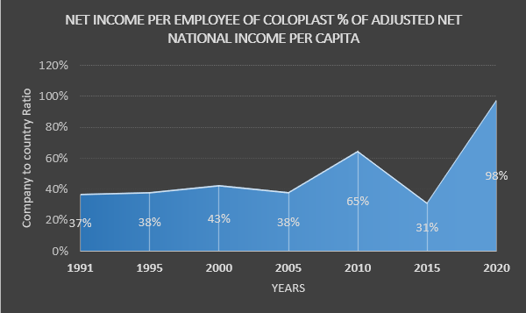

Market Capitalization

|  |  |  |  |  |  |  |  |
| --- | --- | --- | --- | --- | --- | --- | --- |
| **YEARS** | Market cap in DENMARK in BILLION US  $ | COLOPLAST | | **YEARS** | Market cap in DENMARK in BILLION  US $ | COLOPLAST | |
| Market Cap in billions | Percentage | Market Cap in billions | Percentage |
| **1995** | 56.22 | 0.56627 | 1% | **2009** | NA | 3.50108 | NA |
| **1996** | 71.07 | 0.77234 | 1% | **2010** | 207.2397 | 5.37506 | 3% |
| **1997** | 93.77 | 0.86743 | 1% | **2011** | 164.55296 | 6.07134 | 4% |
| **1998** | 98.87 | 1.07683 | 1% | **2012** | 198.08958 | 8.77333 | 4% |
| **1999** | 97.45 | 1.20832 | 1% | **2013** | 248.53962 | 11.97897 | 5% |
| **2000** | 111.81 | 0.99435 | 1% | **2014** | 282.4317 | 17.64517 | 6% |
| **2001** | 85.14 | 1.63045 | 2% | **2015** | 367.683516 | 14.97236 | 4% |
| **2002** | 76.74 | 0.12688 | 0% | **2016** | 351.832491 | 16.41041 | 5% |
| **2003** | 121.64 | 1.97122 | 2% | **2017** | 397.010636 | 17.19814 | 4% |
| **2004** | 151.34 | 2.32084 | 2% | **2018** | 341.00462 | 21.72255 | 6% |
| **2005** | NA | 2.82661 | NA | **2019** | 427.121732 | 25.59164 | 6% |
| **2006** | NA | 3.85852 | NA | **2020** | 530.168821 | 33.60342 | 6% |
| **2007** | NA | 4.17755 | NA | **2021** | 637.84149 | 33.32569 | 5% |
| **2008** | NA | 3.12851 | NA |  | | | |

**Source: Bloomberg and World Bank**

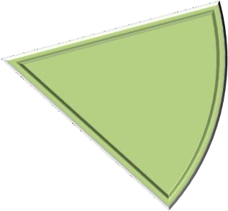

COLOPLAST Market Cap % Market Cap of Denmark

1.007%

0.889%

1.534%

6.338%

2.594%

4.072%

1995 2000 2004 2010 2015 2020

Capital Formation

|  |  |  |  |  |  |  |  |
| --- | --- | --- | --- | --- | --- | --- | --- |
| **Years** | Capital Formation of DENMARK In  US Billion $ | COLOPLAST | | **Years** | Capital Formation of DENMARK In  US Billion $ | COLOPLAST | |
| Total Equity in Billions of  USD | Percentage | Total Equity in Billions of  USD | Percentage |
| **1991** | 27.3 | 0.0761 | 0.2788% | **2007** | 80.74 | 0.4583 | 0.5676% |
| **1992** | 28.96 | 0.1018 | 0.3515% | **2008** | 84.75 | 0.4319 | 0.5096% |
| **1993** | 24.88 | 0.0977 | 0.3927% | **2009** | 61.32 | 0.5606 | 0.9142% |
| **1994** | 29.26 | 0.0944 | 0.3226% | **2010** | 58.2 | 0.631 | 1.0842% |
| **1995** | 38.27 | 0.1382 | 0.3611% | **2011** | 65.8 | 0.8093 | 1.2299% |
| **1996** | 37.65 | 0.1528 | 0.4058% | **2012** | 63.66 | 1.0435 | 1.6392% |
| **1997** | 38.29 | 0.1585 | 0.4139% | **2013** | 67.65 | 1.228 | 1.8152% |
| **1998** | 40.1 | 0.1818 | 0.4534% | **2014** | 70.9 | 1.0659 | 1.5034% |
| **1999** | 37.7 | 0.2008 | 0.5326% | **2015** | 62.45 | 0.7053 | 1.1294% |
| **2000** | 36.69 | 0.179 | 0.4879% | **2016** | 68.18 | 0.7642 | 1.1209% |
| **2001** | 35.96 | 0.1289 | 0.3585% | **2017** | 73.24 | 0.9441 | 1.2890% |
| **2002** | 38.13 | 0.185 | 0.4852% | **2018** | 80.64 | 0.9995 | 1.2395% |
| **2003** | 45.63 | 0.3167 | 0.6941% | **2019** | 75.72 | 1.0095 | 1.3332% |
| **2004** | 54.53 | 0.3945 | 0.7235% | **2020** | 80.5 | 1.1661 | 1.4486% |
| **2005** | 58.73 | 0.4052 | 0.6899% | **2021** | 91.49 | 1.2709 | 1.3891% |
| **2006** | 68.74 | 0.4772 | 0.6942% |  | | | |

**Source: Bloomberg and World Bank**

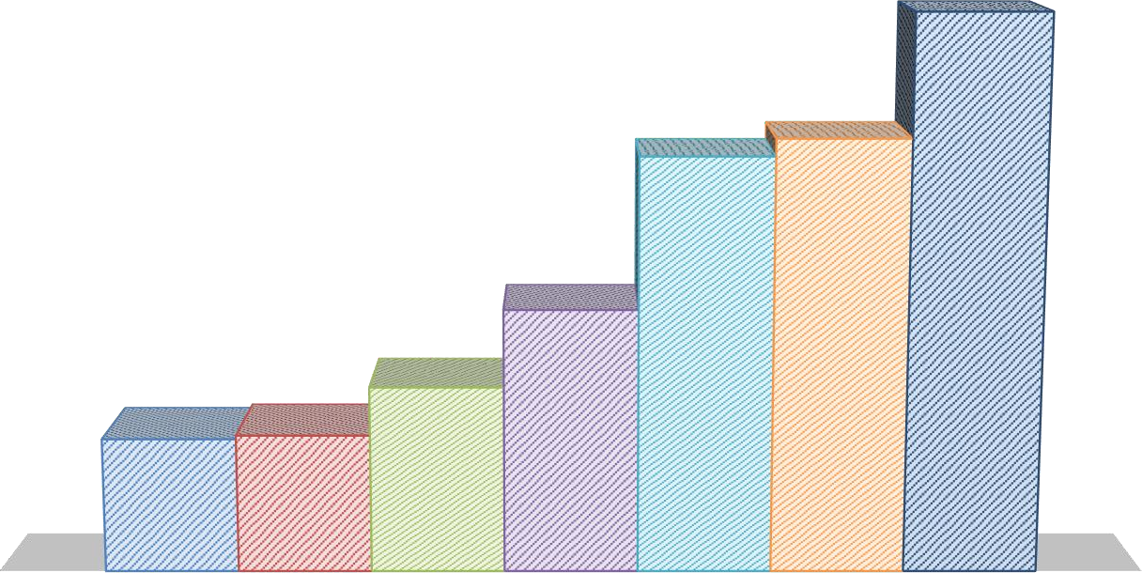

**COLOPLAST TOTAL EQUITY % OF CAPITAL FORMATION OF**

**DENMARK**

FY 1992 FY 1995 FY 2000 FY 2005 FY 2010 FY 2015 FY 2020

1.600%

1.449%

1.400%

1.200%

1.084%

1.129%

1.000%

0.800%

0.690%

0.600%

0.488%

0.400%

0.352%

0.361%

0.200%

0.000%

COLOPLAST Total Equity % OF CAPITAL FORMATION of Denmark

# DSV AS

* Founded in 1976, DSV AS (DSV), originally known as DSV Panalpina AS, is a company that offers logistics and transportation services.
* The business provides customary sea freight services, such as complete container load, buyer's consolidation services, and non-containerized load, in addition to normal air freight services like full charter and on-board courier.
* The corporation has activities throughout Asia-Pacific, the Americas, Europe, the Middle East, and Africa.
* Hedehusene, Denmark serves as the home office for DSV.
* For the fiscal year that ended in December 2021 (FY2021), the firm recorded revenues of (Danish Krone) DKK182,306 million, an increase of 57.3% over FY2020. For the first quarter that concluded in March 2022, the firm recorded revenues of DKK61,125 million, a 0.3% decline from the prior quarter.

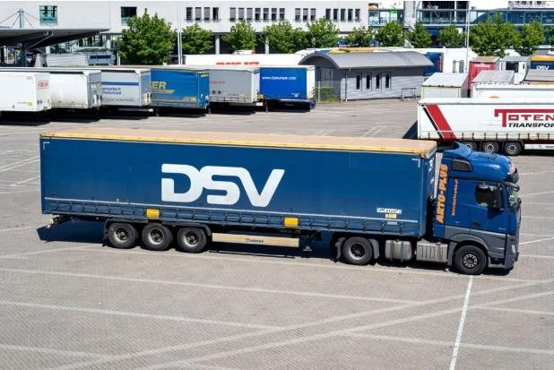

GDP

|  |  |  |  |  |  |  |  |
| --- | --- | --- | --- | --- | --- | --- | --- |
| **Years** | Denmark ($ Millions) | DSV | Percentage | **Years** | Denmark ($ Millions) | DSV | Percentage |
| **1991** | 204830 | 859.6 | 0.00000042% | **2007** | 294567 | 34899 | 0.00001185% |
| **1992** | 208838 | 886.4 | 0.00000042% | **2008** | 293059 | 37435 | 0.00001277% |
| **1993** | 208861 | 859.7 | 0.00000041% | **2009** | 278680 | 36085 | 0.00001295% |
| **1994** | 219998 | 895.6 | 0.00000041% | **2010** | 283894 | 42562 | 0.00001499% |
| **1995** | 226659 | 1126.8 | 0.00000050% | **2011** | 287689 | 43710 | 0.00001519% |
| **1996** | 233232 | 1236.1 | 0.00000053% | **2012** | 288341 | 44912 | 0.00001558% |
| **1997** | 240837 | 1426.7 | 0.00000059% | **2013** | 291032 | 45710 | 0.00001571% |
| **1998** | 246180 | 2712.8 | 0.00000110% | **2014** | 295745 | 48582 | 0.00001643% |
| **1999** | 253437 | 3660.3 | 0.00000144% | **2015** | 302673 | 50869 | 0.00001681% |
| **2000** | 262933 | 4417.3 | 0.00000168% | **2016** | 312498 | 67747 | 0.00002168% |
| **2001** | 265097 | 48 | 0.00000002% | **2017** | 321316 | 74901 | 0.00002331% |
| **2002** | 266334 | 18123 | 0.00000680% | **2018** | 327708 | 79771 | 0.00002434% |
| **2003** | 267372 | 17871 | 0.00000668% | **2019** | 334638 | 96025 | 0.00002870% |
| **2004** | 274507 | 18092 | 0.00000659% | **2020** | 327738 | 117358 | 0.00003581% |
| **2005** | 280921 | 23015 | 0.00000819% | **2021** | 343120 | 182590 | 0.00005321% |
| **2006** | 291913 | 31972 | 0.00001095% |  |  |  |  |

**Source: Bloomberg and World Bank**

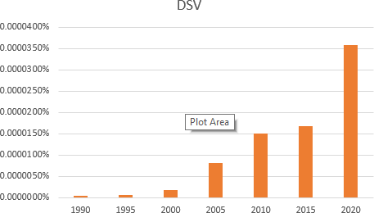

Employment

|  |  |  |  |  |  |  |  |
| --- | --- | --- | --- | --- | --- | --- | --- |
| **Years** | Population Employed | DSV | | **Years** | Population Employed | DSV | |
| Number of  Employees | Percentage | Number of  Employees | Percentage |
| **1991** | 31,77,986 | 568 | 0.0179% | **2007** | 34,52,339 | 19,211 | 0.5565% |
| **1992** | 32,04,181 | 365 | 0.0114% | **2008** | 34,43,676 | 21,280 | 0.6179% |
| **1993** | 31,20,856 | 304 | 0.0097% | **2009** | 33,28,383 | 21,300 | 0.6400% |
| **1994** | 30,82,267 | 335 | 0.0109% | **2010** | 32,49,777 | 21,678 | 0.6671% |
| **1995** | 31,44,943 | 402 | 0.0128% | **2011** | 32,39,343 | 21,932 | 0.6771% |
| **1996** | 31,96,791 | 453 | 0.0142% | **2012** | 32,12,358 | 22,021 | 0.6855% |
| **1997** | 32,71,726 | 483 | 0.0148% | **2013** | 31,94,166 | 22,874 | 0.7161% |
| **1998** | 32,83,046 | 1,466 | 0.0447% | **2014** | 32,17,627 | 22,783 | 0.7081% |
| **1999** | 33,21,760 | 1,620 | 0.0488% | **2015** | 32,66,241 | 44,779 | 1.3710% |
| **2000** | 33,42,813 | 1,868 | 0.0559% | **2016** | 33,19,783 | 45,646 | 1.3750% |
| **2001** | 33,46,024 | 10,459 | 0.3126% | **2017** | 33,50,722 | 47,394 | 1.4144% |
| **2002** | 33,78,074 | 9,971 | 0.2952% | **2018** | 33,97,909 | 61,216 | 1.8016% |
| **2003** | 33,39,137 | 9,249 | 0.2770% | **2019** | 34,44,405 | 56,621 | 1.6439% |
| **2004** | 33,77,935 | 9,225 | 0.2731% | **2020** | 34,12,654 | 77,958 | 2.2844% |
| **2005** | 33,86,007 | 11,619 | 0.3431% | **2021** | 34,64,258 | 76,715 | 2.2145% |
| **2006** | 34,45,001 | 19,199 | 0.5573% |  | | | |

**Source: Bloomberg and World Bank**



**NUMBER OF EMPLOYEES DSV % OF POPULATION**

**EMPLOYED OF DENMARK**

Number of Employees DSV % of POPULATION EMPLOYED OF DENMARK

**2.2844%**

**2.2145%**

**1.3710%**

**0.6671%**

**0.3431%**

**0.0179%**

**0.0128%**

**0.0559%**

1991

1995

2000

2005

2010

2015

2020

2021

National Per Capita Income

|  |  |  |  |  |  |  |  |
| --- | --- | --- | --- | --- | --- | --- | --- |
| **Years** | Adjusted net national income per capita of Denmark ($) | DSV | | **Years** | Adjusted net national income per capita of Denmark ($) | DSV | |
| Net income per employee  ($) | Percentage | Net income per employee  ($) | Percentage |
| **1991** | 21,534.74 | -1,211.12 | -6% | **2007** | 47,957.84 | 10,218.56 | 21% |
| **1992** | 23,748.69 | 7,260.72 | 31% | **2008** | 52,148.61 | **NA** | NA |
| **1993** | 22,305.79 | 15,142.23 | 68% | **2009** | 47,483.32 | 1,628.12 | 3% |
| **1994** | 24,413.92 | 14,236.16 | 58% | **2010** | 47,959.01 | 9,902.14 | 21% |
| **1995** | 28,870.71 | 16,105.44 | 56% | **2011** | 51,228.62 | 12,413.88 | 24% |
| **1996** | 29,023.87 | 21,362.22 | 74% | **2012** | 48,814.47 | 11,239.56 | 23% |
| **1997** | 26,622.04 | 21,880.91 | 82% | **2013** | 51,794.62 | 12,754.76 | 25% |
| **1998** | 27,247.51 | 7,394.22 | 27% | **2014** | 53,767.20 | 11,607.62 | 22% |
| **1999** | 27,394.91 | 10,107.94 | 37% | **2015** | 45,788.04 | 13,430.06 | 29% |
| **2000** | 24,600.59 | 9,922.18 | 40% | **2016** | 46,821.19 | 5,537.58 | 12% |
| **2001** | 24,788.12 | **NA** | NA | **2017** | 49,134.60 | 9,917.93 | 20% |
| **2002** | 26,747.43 | 4,250.76 | 16% | **2018** | 52,848.82 | 13,374.92 | 25% |
| **2003** | 32,660.80 | 5,008.83 | 15% | **2019** | 51,399.61 | 9,062.79 | 18% |
| **2004** | 38,088.41 | 19,633.17 | 52% | **2020** | 52,666.35 | 11,497.17 | 22% |
| **2005** | 40,314.94 | 9,455.56 | 23% | **2021** | NA | 22,858.78 | NA |
| **2006** | 43,110.23 | 5,939.45 | 14% |  | | | |

**Source: Bloomberg and World Bank**

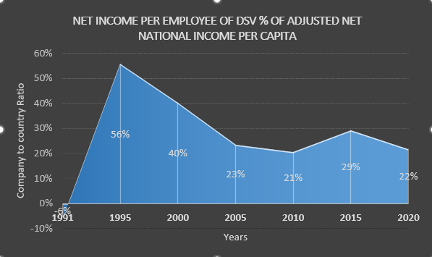

Market Capitalization

|  |  |  |  |  |  |  |  |
| --- | --- | --- | --- | --- | --- | --- | --- |
| **Years** | Market cap in DENMARK in BILLION  US $ | DSV | | **Years** | Market cap in DENMARK in BILLION  US $ | DSV | |
| Market Cap in Billions | Percentage | Market Cap in Billions | Percentage |
| **1995** | 56.22 | 0.07042 | 0.125% | **2009** | NA | 3.7786 | NA |
| **1996** | 71.07 | 0.08231 | 0.116% | **2010** | 207.2397 | 4.56599 | 2.203% |
| **1997** | 93.77 | 0.1656 | 0.177% | **2011** | 164.55296 | 3.3338 | 2.026% |
| **1998** | 98.87 | 0.31357 | 0.317% | **2012** | 198.08958 | 4.58921 | 2.317% |
| **1999** | 97.45 | 1.38681 | 1.423% | **2013** | 248.53962 | 5.7382 | 2.309% |
| **2000** | 111.81 | 0.36298 | 0.325% | **2014** | 282.4317 | 5.19337 | 1.839% |
| **2001** | 85.14 | 0.51011 | 0.599% | **2015** | 367.683516 | 7.27458 | 1.978% |
| **2002** | 76.74 | 0.48861 | 0.637% | **2016** | 351.832491 | 8.16732 | 2.321% |
| **2003** | 121.64 | 0.87981 | 0.723% | **2017** | 397.010636 | 14.52654 | 3.659% |
| **2004** | 151.34 | 1.32784 | 0.877% | **2018** | 341.00462 | 11.71796 | 3.436% |
| **2005** | NA | 2.44454 | NA | **2019** | 427.121732 | 26.40639 | 6.182% |
| **2006** | NA | 3.62605 | NA | **2020** | 530.168821 | 37.83406 | 7.136% |
| **2007** | NA | 4.1178 | NA | **2021** | 637.84149 | 55.14019 | 8.645% |
| **2008** | NA | 1.9367 | NA |  | | | |

**Source: Bloomberg and World Bank**

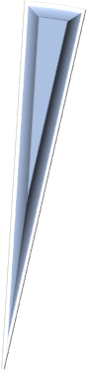

DSV Market Cap % Market Cap of Denmark

0.13%

0.32%

0.88%

2.20%

7.14%

1.98%

1995 2000 2004 2010 2015 2020

Capital Formation

|  |  |  |  |  |  |  |  |
| --- | --- | --- | --- | --- | --- | --- | --- |
| **Years** | Capital Formation of DENMARK In  US Billion $ | DSV | | **Years** | Capital Formation of DENMARK In  US Billion $ | DSV | |
| Total Equity in BILLION  USD | Percentage | Total Equity in BILLION  USD | Percentage |
| **1991** | 27.3 | 0.0182 | 0.0667% | **2007** | 80.74 | 0.7137 | 0.8839% |
| **1992** | 28.96 | 0.0246 | 0.0849% | **2008** | 84.75 | 0.723 | 0.8531% |
| **1993** | 24.88 | 0.0247 | 0.0993% | **2009** | 61.32 | 1.0651 | 1.7370% |
| **1994** | 29.26 | 0.0316 | 0.1080% | **2010** | 58.2 | 1.1808 | 2.0289% |
| **1995** | 38.27 | 0.0427 | 0.1116% | **2011** | 65.8 | 0.9256 | 1.4067% |
| **1996** | 37.65 | 0.0493 | 0.1309% | **2012** | 63.66 | 0.9526 | 1.4964% |
| **1997** | 38.29 | 0.049 | 0.1280% | **2013** | 67.65 | 1.1549 | 1.7072% |
| **1998** | 40.1 | 0.0617 | 0.1539% | **2014** | 70.9 | 0.9883 | 1.3939% |
| **1999** | 37.7 | 0.0741 | 0.1966% | **2015** | 62.45 | 1.724 | 2.7606% |
| **2000** | 36.69 | 0.0805 | 0.2194% | **2016** | 68.18 | 1.8977 | 2.7834% |
| **2001** | 35.96 | 0.2509 | 0.6977% | **2017** | 73.24 | 2.3916 | 3.2654% |
| **2002** | 38.13 | 0.3197 | 0.8384% | **2018** | 80.64 | 2.2289 | 2.7640% |
| **2003** | 45.63 | 0.4174 | 0.9147% | **2019** | 75.72 | 7.4115 | 9.7880% |
| **2004** | 54.53 | 0.5816 | 1.0666% | **2020** | 80.5 | 7.77 | 9.6522% |
| **2005** | 58.73 | 0.527 | 0.8973% | **2021** | 91.49 | 11.3726 | 12.4304% |
| **2006** | 68.74 | 0.6799 | 0.9891% |  | | | |

**Source: Bloomberg and World Bank**

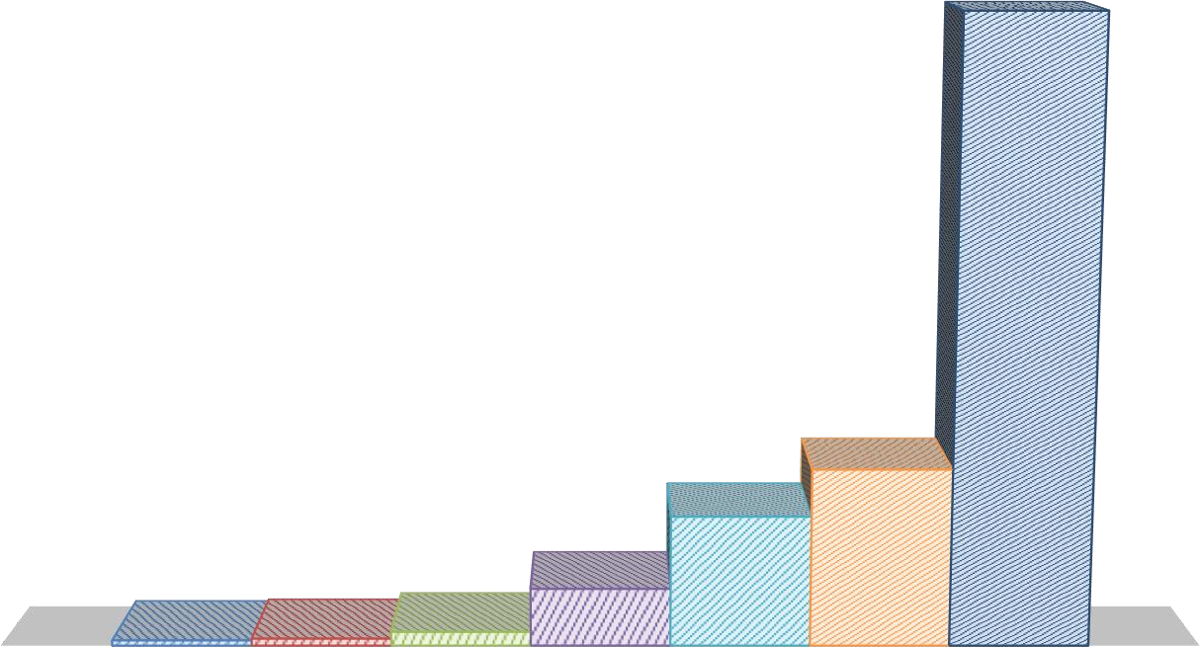

**DSV TOTAL EQUITY % OF CAPITAL FORMATION OF**

**DENMARK**

FY 1992 FY 1995 FY 2000 FY 2005 FY 2010 FY 2015 FY 2020

10.000%

9.652%

9.000%

8.000%

7.000%

6.000%

5.000%

4.000%

3.000%

2.761%

2.029%

2.000%

0.897%

1.000%

0.085%

0.112%

0.219%

0.000%

DSV Total Equity % OF CAPITAL FORMATION of Denmark

# DEMANT COMPANY

* With a history of care, health, and innovation dating back to 1904, Demant is a leading global provider of hearing healthcare and technology.
* In order to interact and communicate with the world around them, with businesses in more than 30 countries, The Demant Group operates on a worldwide scale, employs close to 20,000 people, and brings in more than DKK 18 billion annually.
* Europe and North America are by far the two largest markets for hearing healthcare, with a market value of about USD 24 billion annually. Market growth rates for hearing aids and implants are predicted to be 2-4% and 10-15%, respectively. Revenue.
* Demant brought in 18,418 million DKK in 2021. Europe and North America are their two biggest markets.



GDP

|  |  |  |  |  |  |  |  |
| --- | --- | --- | --- | --- | --- | --- | --- |
| **Years** | Denmark ($ Millions) | Demant | Percentage | **Years** | Denmark ($ Millions) | Demant | Percentage |
| **1991** | 204830 | **NA** | NA | **2007** | 294567 | 6235.4 | 0.00000212% |
| **1992** | 208838 | 688.8 | 0.00000033% | **2008** | 293059 | 6124 | 0.00000209% |
| **1993** | 208861 | 801.3 | 0.00000038% | **2009** | 278680 | 6497.7 | 0.00000233% |
| **1994** | 219998 | 894.4 | 0.00000041% | **2010** | 283894 | 7885.5 | 0.00000278% |
| **1995** | 226659 | 1138.9 | 0.00000050% | **2011** | 287689 | 9123 | 0.00000317% |
| **1996** | 233232 | 1312.6 | 0.00000056% | **2012** | 288341 | 9569 | 0.00000332% |
| **1997** | 240837 | 1691.9 | 0.00000070% | **2013** | 291032 | 10101 | 0.00000347% |
| **1998** | 246180 | 1914.3 | 0.00000078% | **2014** | 295745 | 10549 | 0.00000357% |
| **1999** | 253437 | 2256.6 | 0.00000089% | **2015** | 302673 | 11989 | 0.00000396% |
| **2000** | 262933 | 3459.1 | 0.00000132% | **2016** | 312498 | 13302 | 0.00000426% |
| **2001** | 265097 | 4179.3 | 0.00000158% | **2017** | 321316 | 14540 | 0.00000453% |
| **2002** | 266334 | 4537.8 | 0.00000170% | **2018** | 327708 | 15578 | 0.00000475% |
| **2003** | 267372 | 4442.7 | 0.00000166% | **2019** | 334638 | 16798 | 0.00000502% |
| **2004** | 274507 | 4905.4 | 0.00000179% | **2020** | 327738 | 16437 | 0.00000502% |
| **2005** | 280921 | 5348.4 | 0.00000190% | **2021** | 343120 | 20271 | 0.00000591% |
| **2006** | 291913 | 5706.2 | 0.00000195% |  | | | |

**Source: Bloomberg and World Bank**

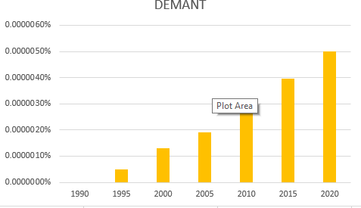

Employment

|  |  |  |  |  |  |  |  |
| --- | --- | --- | --- | --- | --- | --- | --- |
| **Years** | Population Employed | Demant | | **Years** | Population Employed | Demant | |
| Number of  Employees | Percentage | Number of  Employees | Percentage |
| **1991** | 31,77,986 | **NA** | NA | **2007** | 34,52,339 | 5,091 | 0.1475% |
| **1992** | 32,04,181 | 1,069 | 0.0334% | **2008** | 34,43,676 | 5,542 | 0.1609% |
| **1993** | 31,20,856 | 1,073 | 0.0344% | **2009** | 33,28,383 | 5,833 | 0.1753% |
| **1994** | 30,82,267 | 1,192 | 0.0387% | **2010** | 32,49,777 | 7,098 | 0.2184% |
| **1995** | 31,44,943 | 1,485 | 0.0472% | **2011** | 32,39,343 | 7,748 | 0.2392% |
| **1996** | 31,96,791 | 1,443 | 0.0451% | **2012** | 32,12,358 | 4,890 | 0.1522% |
| **1997** | 32,71,726 | 1,760 | 0.0538% | **2013** | 31,94,166 | 9,514 | 0.2979% |
| **1998** | 32,83,046 | 1,925 | 0.0586% | **2014** | 32,17,627 | 9,799 | 0.3045% |
| **1999** | 33,21,760 | 2,132 | 0.0642% | **2015** | 32,66,241 | 10,803 | 0.3307% |
| **2000** | 33,42,813 | 3,323 | 0.0994% | **2016** | 33,19,783 | 12,671 | 0.3817% |
| **2001** | 33,46,024 | 3,997 | 0.1195% | **2017** | 33,50,722 | 13,280 | 0.3963% |
| **2002** | 33,78,074 | 4,208 | 0.1246% | **2018** | 33,97,909 | 14,250 | 0.4194% |
| **2003** | 33,39,137 | 4,272 | 0.1279% | **2019** | 34,44,405 | 15,352 | 0.4457% |
| **2004** | 33,77,935 | 4,490 | 0.1329% | **2020** | 34,12,654 | 16,591 | 0.4862% |
| **2005** | 33,86,007 | 4,809 | 0.1420% | **2021** | 34,64,258 | 17,500 | 0.5052% |
| **2006** | 34,45,001 | 4,818 | 0.1399% |  | | | |

**Source: Bloomberg and World Bank**



**NUMBER OF EMPLOYEES DEMANT % OF POPULATION**

**EMPLOYED OF DENMARK**

Number of Employees DEMANT % of POPULATION EMPLOYED OF DENMARK

**0.4862%**

**0.5052%**

**0.3307%**

**0.2184%**

**0.1420%**

**0.0994%**

**0.0472%**

**0.0000%**

1991

1995

2000

2005

2010

2015

2020

2021

National Per Capita Income

|  |  |  |  |  |  |  |  |
| --- | --- | --- | --- | --- | --- | --- | --- |
| **Years** | Adjusted net national income per capita of Denmark ($) | Demant | | **Years** | Adjusted net national income per capita of Denmark ($) | Demant | |
| Net income per employee  ($) | Percentage | Net income per employee  ($) | Percentage |
| **1991** | 21,534.74 | **NA** | NA | **2007** | 47,957.84 | **NA** | NA |
| **1992** | 23,748.69 | 1,370.09 | 6% | **2008** | 52,148.61 | 24,290.54 | 47% |
| **1993** | 22,305.79 | 8,963.73 | 40% | **2009** | 47,483.32 | 25,521.50 | 54% |
| **1994** | 24,413.92 | 11,688.94 | 48% | **2010** | 47,959.01 | 24,805.83 | 52% |
| **1995** | 28,870.71 | 11,936.79 | 41% | **2011** | 51,228.62 | 28,895.57 | 56% |
| **1996** | 29,023.87 | 14,385.61 | 50% | **2012** | 48,814.47 | 24,025.84 | 49% |
| **1997** | 26,622.04 | 12,775.69 | 48% | **2013** | 51,794.62 | 24,055.68 | 46% |
| **1998** | 27,247.51 | 15,595.21 | 57% | **2014** | 53,767.20 | 24,113.53 | 45% |
| **1999** | 27,394.91 | 17,305.25 | 63% | **2015** | 45,788.04 | 19,782.26 | 43% |
| **2000** | 24,600.59 | 15,873.44 | 65% | **2016** | 46,821.19 | 17,117.59 | 37% |
| **2001** | 24,788.12 | 14,474.74 | 58% | **2017** | 49,134.60 | 20,058.26 | 41% |
| **2002** | 26,747.43 | 17,499.96 | 65% | **2018** | 52,848.82 | 20,273.38 | 38% |
| **2003** | 32,660.80 | 22,055.27 | 68% | **2019** | 51,399.61 | 14,279.31 | 28% |
| **2004** | 38,088.41 | 26,683.14 | 70% | **2020** | 52,666.35 | 10,349.34 | 20% |
| **2005** | 40,314.94 | 27,448.88 | 68% | **2021** | NA | 22,837.91 | NA |
| **2006** | 43,110.23 | 31,489.94 | 73% |  | | | |

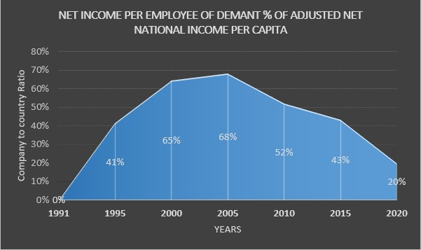

## Source: Bloomberg and World Bank

Market Capitalization

|  |  |  |  |  |  |  |  |
| --- | --- | --- | --- | --- | --- | --- | --- |
| **Years** | Market cap in DENMARK in BILLION  US $ | DEMANT | | **Years** | Market cap in DENMARK in BILLION  US $ | DEMANT | |
| Market Cap in Billions | Percentage | Market Cap in Billions | Percentage |
| **1995** | 56.22 | 0.41154 | 0.732% | **2009** | NA | 4.41125 | NA |
| **1996** | 71.07 | 0.71412 | 1.005% | **2010** | 207.2397 | 4.31097 | 2.080% |
| **1997** | 93.77 | 0.72396 | 0.772% | **2011** | 164.55296 | 4.79973 | 2.917% |
| **1998** | 98.87 | 0.93037 | 0.941% | **2012** | 198.08958 | 4.8501 | 2.448% |
| **1999** | 97.45 | 1.39983 | 1.436% | **2013** | 248.53962 | 5.4998 | 2.213% |
| **2000** | 111.81 | 3.40859 | 3.049% | **2014** | 282.4317 | 4.15149 | 1.470% |
| **2001** | 85.14 | 1.92601 | 2.262% | **2015** | 367.683516 | 5.11428 | 1.391% |
| **2002** | 76.74 | 1.55115 | 2.021% | **2016** | 351.832491 | 4.51502 | 1.283% |
| **2003** | 121.64 | 2.30373 | 1.894% | **2017** | 397.010636 | 7.08383 | 1.784% |
| **2004** | 151.34 | 3.09668 | 2.046% | **2018** | 341.00462 | 6.95448 | 2.039% |
| **2005** | NA | 3.52534 | NA | **2019** | 427.121732 | 7.58442 | 1.776% |
| **2006** | NA | 4.99074 | NA | **2020** | 530.168821 | 9.51361 | 1.794% |
| **2007** | NA | 5.64107 | NA | **2021** | 637.84149 | 12.32014 | 1.932% |
| **2008** | NA | 2.38814 | NA |  | | | |

## Source: Bloomberg and World Bank

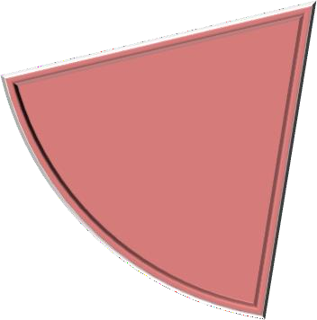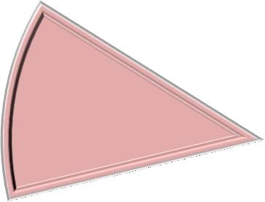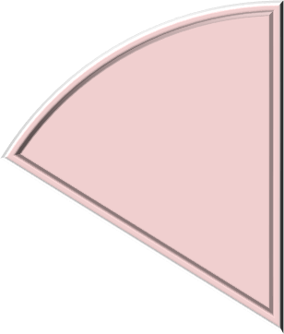

DEMANT Market Cap % Market Cap of Denmark

0.732%

1.794%

3.049%

1.391%

2.080%

2.046%

1995 2000 2004 2010 2015 2020

Capital Formation

|  |  |  |  |  |  |  |  |
| --- | --- | --- | --- | --- | --- | --- | --- |
| **Years** | Capital Formation of DENMARK In  US Billion $ | DEMANT | | **Years** | Capital Formation of DENMARK In  US Billion $ | DEMANT | |
| Total Equity IN BILLION  USD | Percentage | Total Equity IN BILLION  USD | Percentage |
| **1991** | 27.3 | NA | NA | **2007** | 80.74 | 0.085 | 0.1053% |
| **1992** | 28.96 | 0.0233 | 0.0805% | **2008** | 84.75 | 0.1013 | 0.1195% |
| **1993** | 24.88 | 0.0295 | 0.1186% | **2009** | 61.32 | 0.2508 | 0.4090% |
| **1994** | 29.26 | 0.0468 | 0.1599% | **2010** | 58.2 | 0.4381 | 0.7527% |
| **1995** | 38.27 | 0.0834 | 0.2179% | **2011** | 65.8 | 0.5761 | 0.8755% |
| **1996** | 37.65 | 0.0957 | 0.2542% | **2012** | 63.66 | 0.718 | 1.1279% |
| **1997** | 38.29 | 0.0807 | 0.2108% | **2013** | 67.65 | 0.9345 | 1.3814% |
| **1998** | 40.1 | 0.0849 | 0.2117% | **2014** | 70.9 | 0.9075 | 1.2800% |
| **1999** | 37.7 | 0.0679 | 0.1801% | **2015** | 62.45 | 0.9464 | 1.5155% |
| **2000** | 36.69 | 0.0271 | 0.0739% | **2016** | 68.18 | 0.9881 | 1.4493% |
| **2001** | 35.96 | 0.0202 | 0.0562% | **2017** | 73.24 | 1.2004 | 1.6390% |
| **2002** | 38.13 | 0.0605 | 0.1587% | **2018** | 80.64 | 1.0827 | 1.3426% |
| **2003** | 45.63 | 0.088 | 0.1929% | **2019** | 75.72 | 1.1489 | 1.5173% |
| **2004** | 54.53 | 0.1187 | 0.2177% | **2020** | 80.5 | 1.3601 | 1.6896% |
| **2005** | 58.73 | 0.12 | 0.2043% | **2021** | 91.49 | 1.222 | 1.3357% |
| **2006** | 68.74 | 0.1187 | 0.1727% |  | | | |

|  |  |  |
| --- | --- | --- |
| 1.8000% |  | 1.6896% |
| 1.6000% | 1.5155% |  |
| 1.4000% |  |  |
| 1.2000% |  |  |
| 1.0000% |  |  |

**Source: Bloomberg and World Bank**

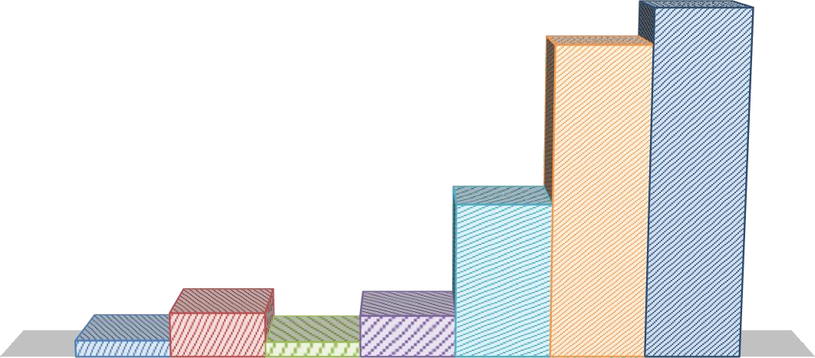

**DEMANT TOTAL EQUITY % OF CAPITAL FORMATION**

**OF DENMARK**

FY 1992 FY 1995 FY 2000 FY 2005 FY 2010 FY 2015 FY 2020

0.8000%

0.7527%

0.6000%

0.4000%

0.2179%

0.2043%

0.2000%

0.0805%

0.0739%

0.0000%

DEMANT Total Equity % OF CAPITAL FORMATION of Denmark

CONCLUSION OF INDICATORS

**COMPARISON OF ALL 5 COMPANIES WITH EACH INDICATOR.**

1. **EMPLOYMENT**

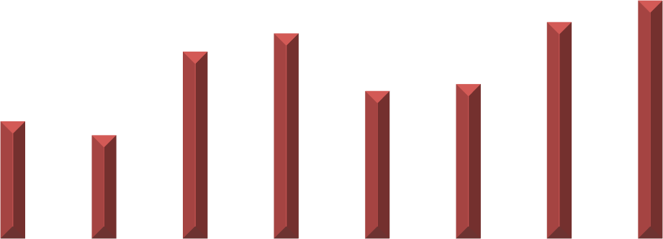

EMPLOYMENT INDICATOR

Population Employed

Number of Employees in DEMANT Number of Employees in NOVO NORDISK

Number of Employees in DSV

Number of Employees in COLOPLAST Number of Employeesin CARLSBERG

250,000 3,500,000

200,000

3,400,000

3,300,000

150,000

3,200,000

100,000

3,100,000

50,000

3,000,000

-

2,900,000

1991 1995 2000 2005 2010 2015 2020 2021

**Source: Bloomberg and World Bank**

1. **GDP**

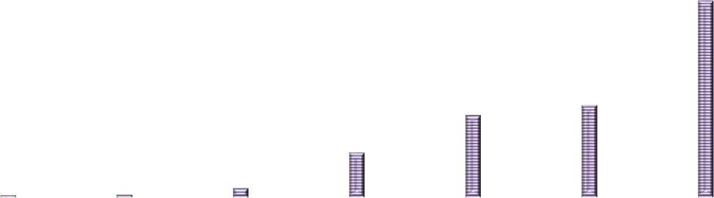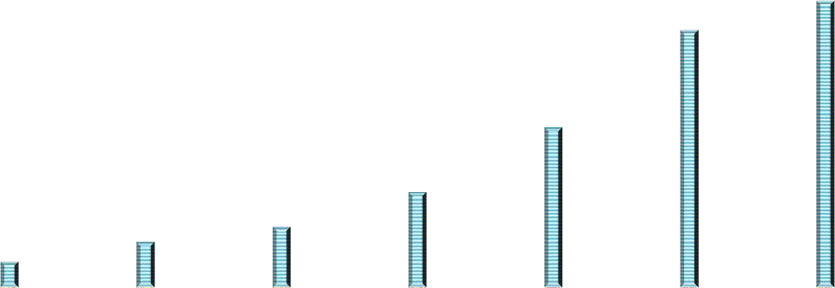

**CO N T R IB UTI ON O F CO M PA N IES I N D E N M A R K' S G D P**

CARLSBERG COLOPLAST DEMANT DSV NOVO

0.0000500%

0.0000450%

0.0000400%

0.0000350%

0.0000300%

0.0000250%

0.0000200%

0.0000150%

0.0000100%

0.0000050%

0.0000000%

1990

1995

2000

2005

2010

2015

2020

**Source: Bloomberg, World Bank and Denmark Statistics**

1. **MARKET CAPITALIZATION**

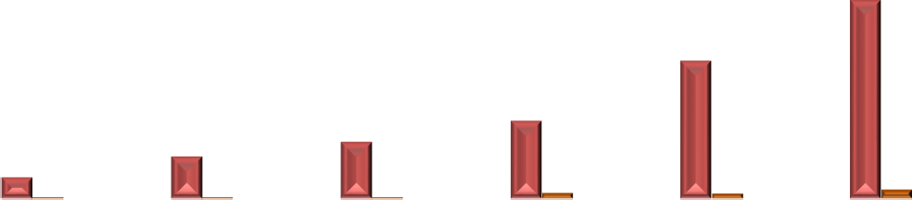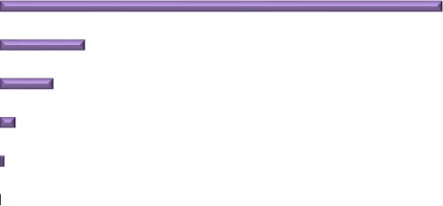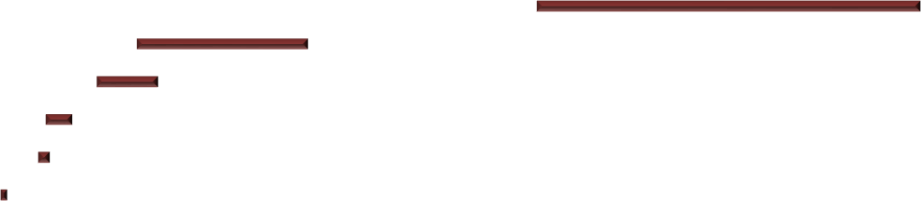

**MARKET CAP INDICATOR**

0

10

20

30

40

50

60

70

80

90

600

500

400

300

200

100

0

1995

2000

2004

2010

2015

2020

Market cap in DENMARK in BILLION US $ CARLSBERG Market Cap

NOVO NORDISK Market Cap DSV Market Cap

DEMANT Market Cap COLOPLAST Market Cap

**Source: Bloomberg, World Bank and Trading Economics**

1. **PER CAPITA INCOME**



**Adjusted net national income per capita of Denmark**

**(US $)**

100%

60000

50000

80%

40000

60%

30000

40%

20000

10000

20%

0

0% -10000

1991 1995 2000 2005 2010 2015 2020

DSV

Adjusted net national income per capita of Denmark ($) Carlsberg

Novo Disk Coloplast

Demant

**Source: Bloomberg and Statista**

1. **CAPITAL FORMATION**

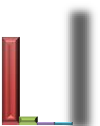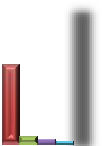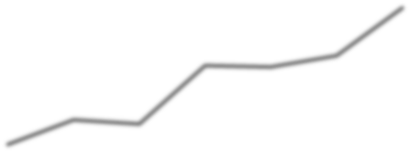

**CAPITAL FORMATION INDICATOR**

25.000%

90

80

20.000%

70

60

15.000%

50

40

10.000%

30

5.000%

20

10

0.000%

0

FY 1992 FY 1995 FY 2000 FY 2005 FY 2010 FY 2015 FY 2020

CARLSBERG Total Equity % OF CAPITAL FORMATION of Denmark COLOPLAST Total Equity % OF CAPITAL FORMATION of Denmark DEMANT Total Equity % OF CAPITAL FORMATION of Denmark DSV Total Equity % OF CAPITAL FORMATION of Denmark

NOVO NORDISK Total Equity % OF CAPITAL FORMATION of Denmark

Capital Formation of DENMARK In US Billion $

**Source: Bloomberg and World Bank**

# Ranking

Parameters:

* + Performance over the years
  + Consistency
  + Low Fluctuation

Rank 1 is highest and Rank 5 is least.

|  |  |  |  |  |  |
| --- | --- | --- | --- | --- | --- |
| **Companies →**  **↓Parameters** | NOVO Nordisk | Carlsberg | Coloplast | DSV | Demant |
| GDP Contribution | 2 | 3 | 5 | 1 | 4 |
| Employment | 4 | 5 | 3 | 2 | 1 |
| Net Income Per Capita | 1 | 4 | 2 | 3 | 5 |
| Market Capitalization | 2 | 5 | 3 | 1 | 4 |
| Capital Formation | 2 | 4 | 5 | 1 | 3 |

1. **GDP Contribution:** We have given DSV rank 1 because of its consistent performance over the years and also, highest increase in contribution (in 1990 its contribution to GDP is 0.0000004% to 2020 its contribution 0.0000358% that is increase by more than 8000% over the years).
2. **Employment:** We have given Demant rank 1 because of its increase in employment over the years. Over the years the employment has increased over 1000% from 1485 employees to 17500 employees.
3. **Net Income Per Capita:** We have Given NOVO Nordisk rank 1 as it per capita income is increased by 841% over the years which is highest in all the countries.
4. **Market Capitalization:** DSV's market capitalization is increased by 50000% over the years, which is highest in all the company taken. So, we give them 1 rank.
5. **Capital Formation:** According to our research DSV is highest in capital Formation over the years.

# References

* BLOOMBERG
* WORLD BANK SITE (<https://www.worldbank.org/en/home>)
* TRADING ECONOMICS (<https://tradingeconomics.com/>)
* STATISTA (<https://www.statista.com/>)
* DENMARK Home country websites
  + STATISTICS DENMARK (<https://www.statbank.dk/20515>)
  + DANMARK NATIONALBANK (<https://www.nationalbanken.dk/en/Pages/Default.aspx>)

**--------------- End of Report ---------------**